Hello world installing Docker :



Docker search Hadoop:

docker-compose up:

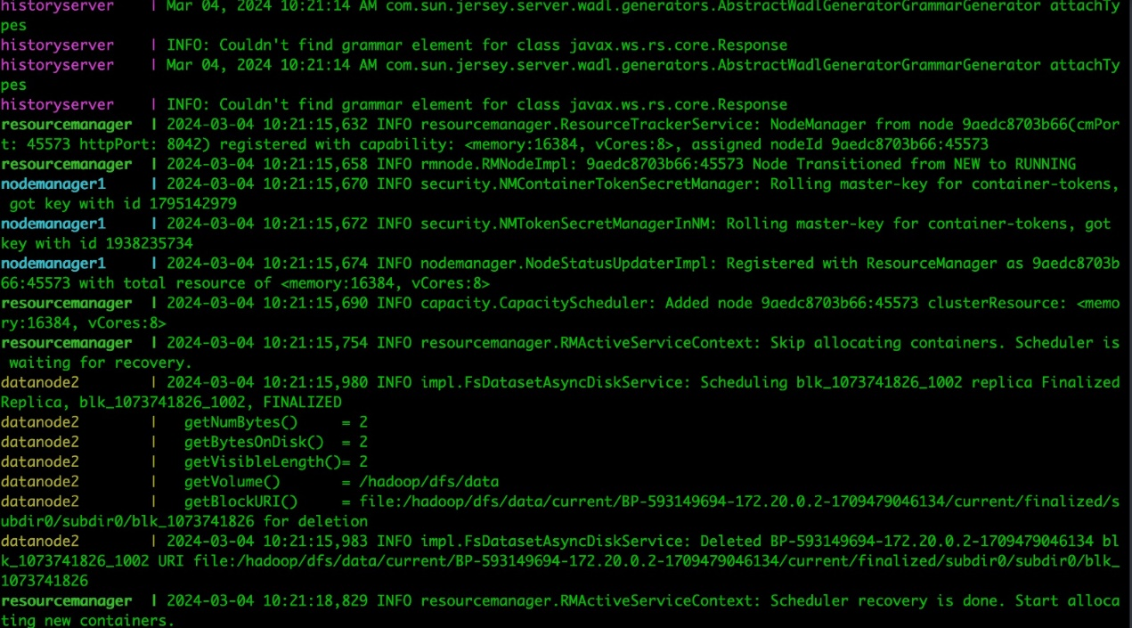

Running of the Docker-compose Hadoop project:

A. Distributed grep:

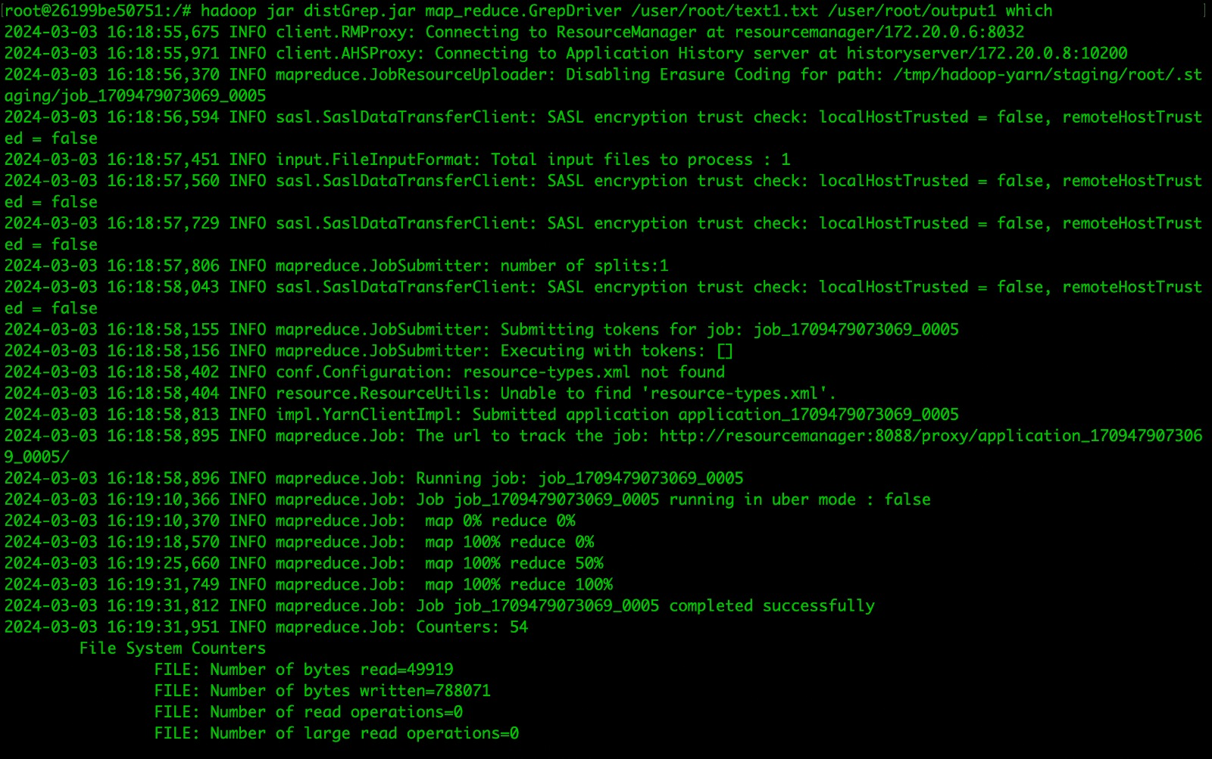פקודת הרצה עבור file1.txt

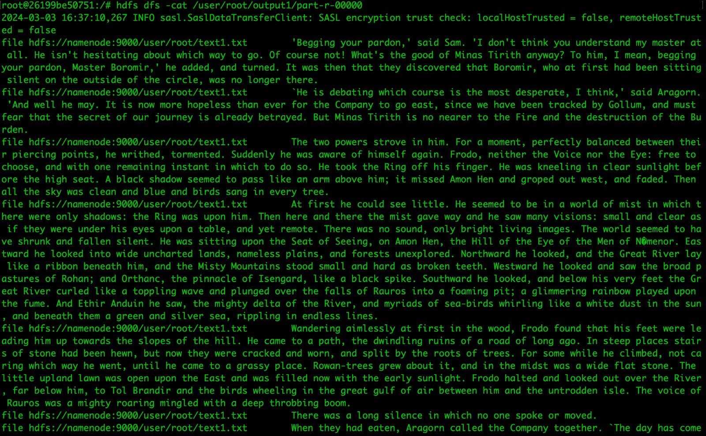תוכן ה output של file1

פקודת הרצה עבור txtfile2.txt

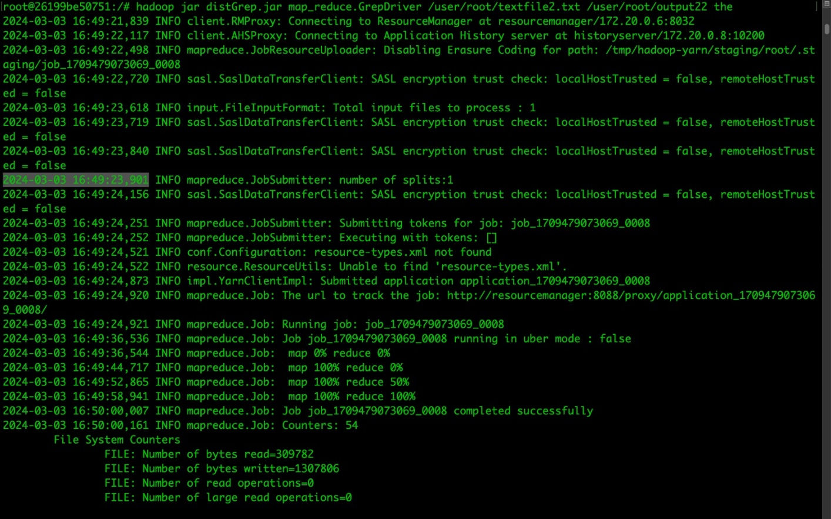

תוכן ה output של txtFile2

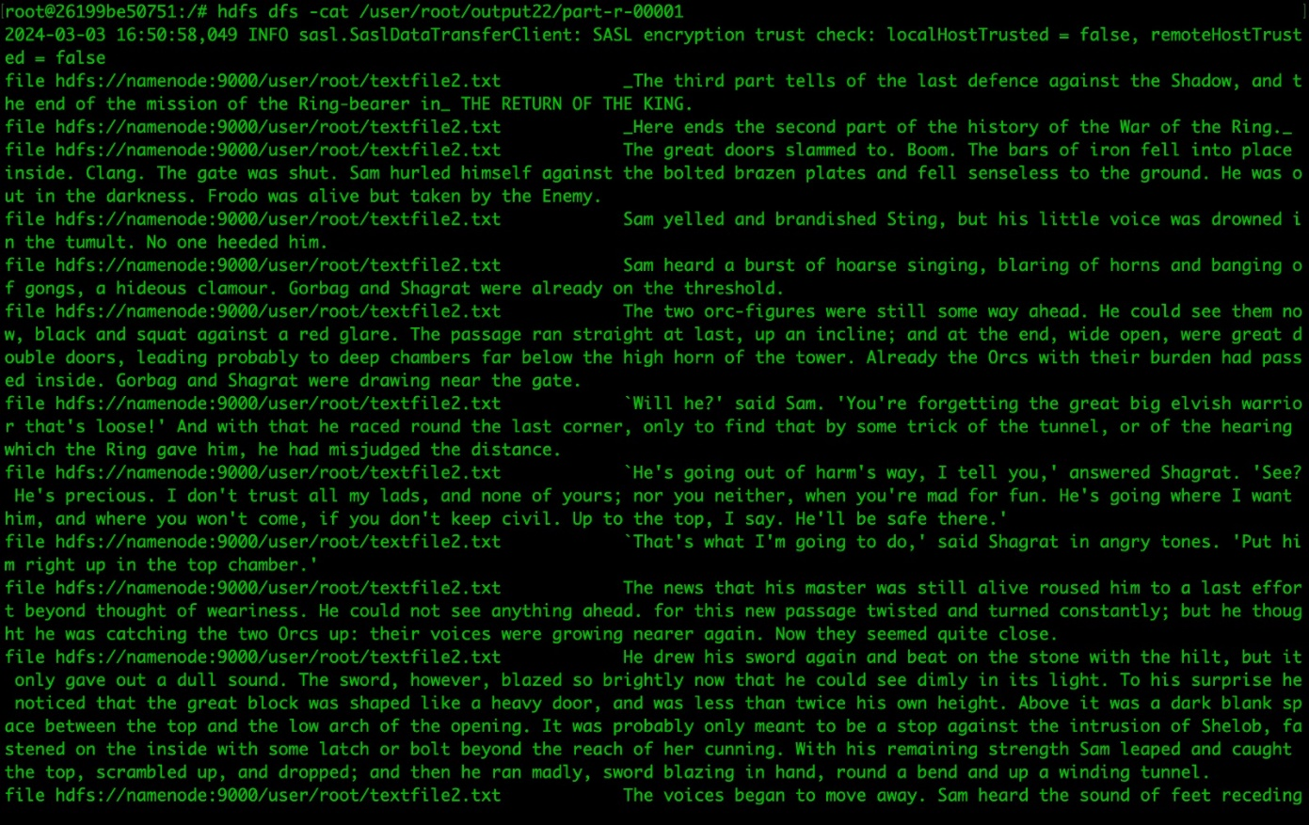

Run command over file 3:

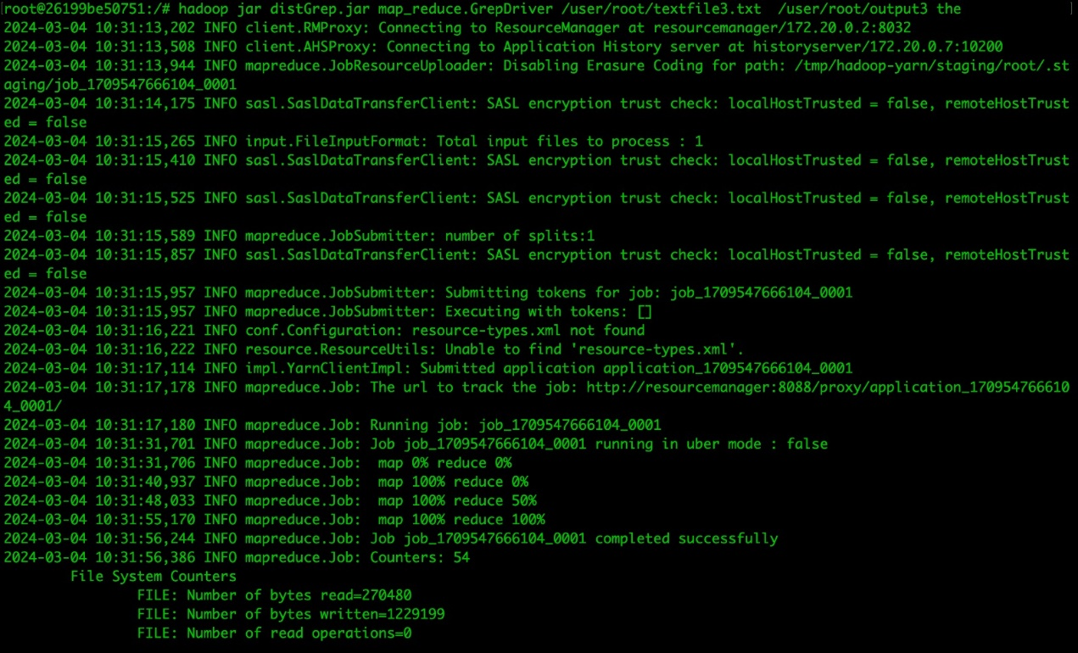

success running command over 3 files:

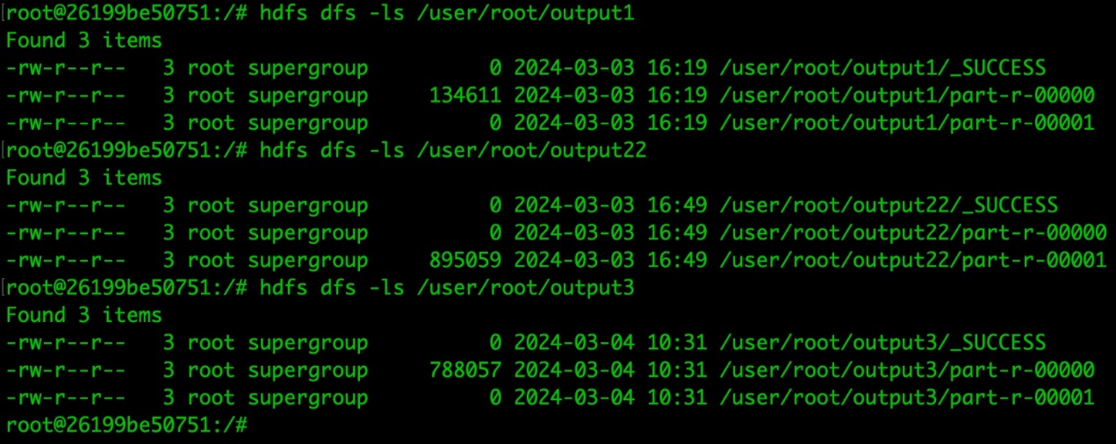

output from file 3:

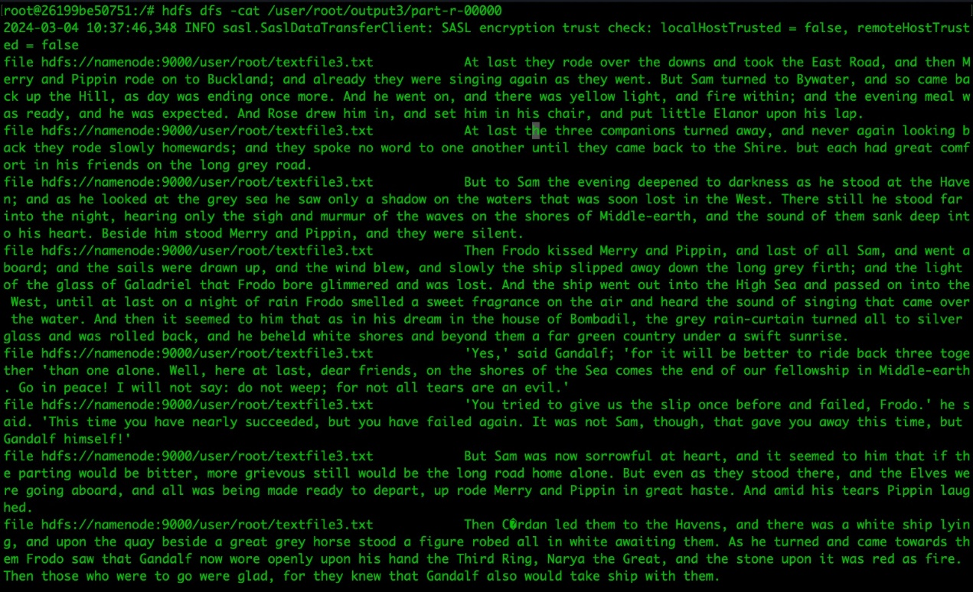

B. Length of words counter:

running command over file1

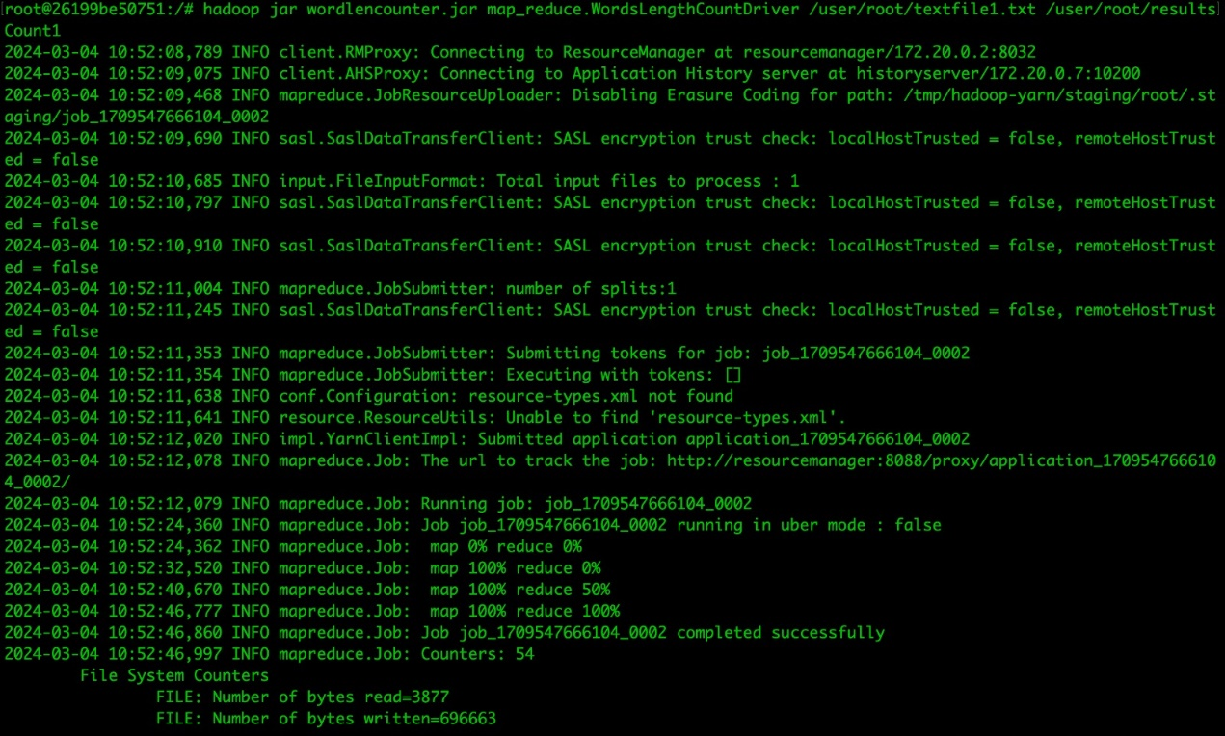

running command over file2:

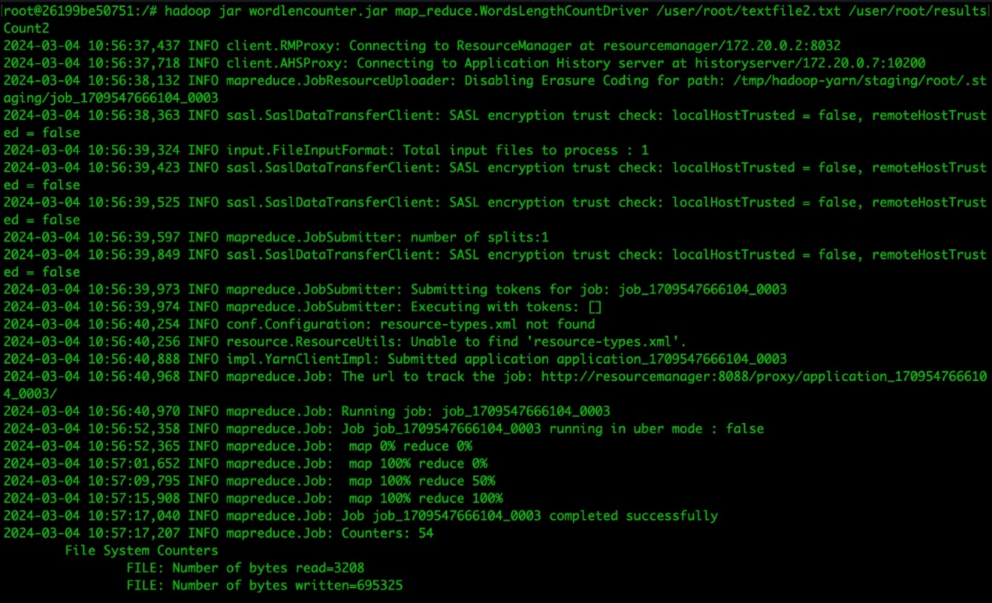

running command over file3:

running succeeded over 3 files:

output file1:

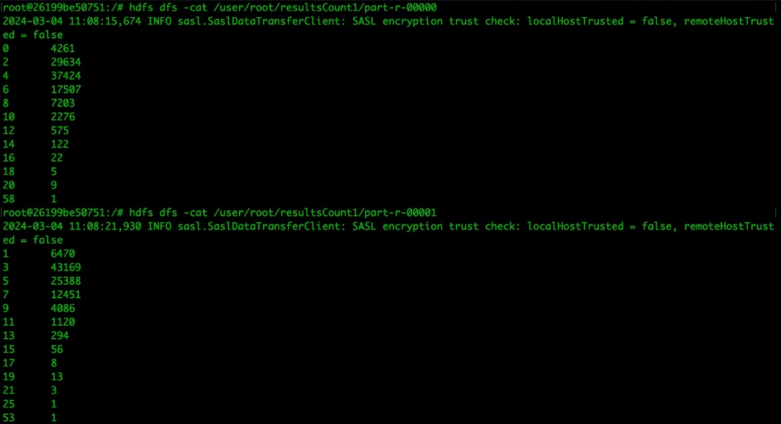

output file 3

